SCOS Fabrication
Preparation
Materials:
- ~65 cm D-fiber
- Latex gloves
- Bare fiber clamp (size 250)
- Fiber stripper
- Fiber cleaver
- Isopropyl alcohol
- Fiber cleaning box
- Etch boat
Procedure:
- Cut approximately 65 cm of D-fiber from the spool. It is called D – fiber because one side of it is round and the other side is flat, like the shape of a D.
- Strip the jackets off the ends of the fiber. Use a 250 bare fiber clamp and place it in the striper. Press down on the top of the stripper until the red light turns green. When the light turns green, slowly pull the end of the wire out of the stripper. Clean the edge with isopropyl alcohol.
- Use the cleaver to chop off the end of the wire and make it a clean straight edge. Do this to both ends of the fiber (steps 2 and 3).
- The center of the fiber needs to be stripped. Strip 2 to 2.5 cm out of the center using the stripper.
- Place fiber in the etch boat. The center should be the stripped region in the center of the fiber. It should be placed with the shiny side (flat side) facing up.
Etching:
Materials:
- Hydroflouric Acid (HF)
- IPA Bath
- Labview
- Distilled water
- HF safety gear (gloves, goggles, apron)
Procedure:

- Clean all three stripped regions with isopropyl alcohol. Make sure to use a sonic cleaner on the middle region.
- Take the fiber to the fume hood and align the fiber so that an ultra-violet laser is shining through a polarizer, then through the fiber, then again through a polarizer that is in the same direction as the first, and finally into an optical power meter. You should be able to get at least 50 uW if not many more.
- Put on the protective equipment including latex gloves, an apron, goggle, face shield, and a set of nitrial gloves. Be very careful using hydrofluoric acid!
- Lower the fiber into the hydrofluoric acid until a little less than 1 cm is submersed in the HF. Make sure that none of the fiber's coating touches the HF. Keep this here for 30 to 100 seconds.
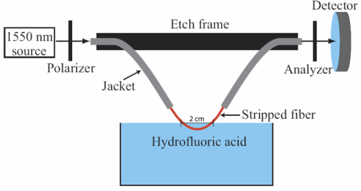
- Using Labview, watch for the power to oscillate 2 times. It should begin at the top oscillate once and then return to minimum power, once it reaches the trough and begins to ascend again, remove the fiber from the HF. This should take about a half hour to reach this point from when it is initially placed in the HF. Be ready with safety gear on once the power starts going down for the second time. The hood should be closed while etching.
- Clean up the fiber using the distilled water and then place it in the IPA bath.
- Place cover back on HF and carefully put it away.
Adjusting the Crystal:
Materials:
- Crystal
- Five Minute Epoxy
- UV Lamp
- Microscope
- UV Adhesive Glue
- Tweezers
- Optical Spectrum Analyzer (OSA)
Procedure:
- UV adhesive glue cures when exposed to UV light. Otherwise it will not harden. For this reason, place the UV adhesive glue on cue tip with the yellow light turned on. This will prevent the glue from beginning to cure inside the bottle. Cover the bottle when the regular lights are turned on and it is no put away in a drawer.
- The fiber cable is set up across the bridge. There should be plenty of extra fiber on each side. One end is attached to the (aligning tool) and the other end is connected via bare fiber adapter as an input to the OSA (Optical Spectrum Analyzer). The fiber should be going flat side up into the bare fiber adapter. The bridge should be underneath the microscope. Adjust the microwave so that the fiber stretched across bridge is in focus under the microscope. A mirror should be placed underneath the wire.
- Using the cue tip to gently apply a small amount of glue to the non-etched portion of the fiber.
- The next steps require a lot of caution because the crystals are expensive and very small. Use tweezers to gently place a crystal on non-etched portion of the fiber. It is more precise to place the crystal on the fiber using the microscope. BE VERY CAREFUL NOT TO STRETCH THE FIBER! Avoid touching the fiber because when pressure is released from the wire the crystal could be fired across the room. The crystals are tiny and clear, so if this happens, there is not a good chance of finding the crystal ever again. BE CAREFUL.
- Chances are the crystal was not placed correctly on the D-fiber. Adjust the crystal (using the microscope and the tweezers) so that the longer end (2 nm) of the crystal runs parallel to the D-fiber and the shorter end runs perpendicular to the D-fiber. In order to get readings from the OSA, the crystal must be on top of the fiber and not underneath the fiber.

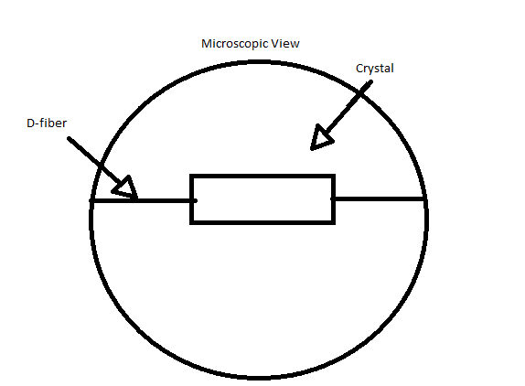
- Once the crystal is aligned correctly, check the display of the OSA to see if the crystal is reflecting enough. If it is correctly placed, the OSA should detect at least 15 dB of resonance between the peak and the minimum power.
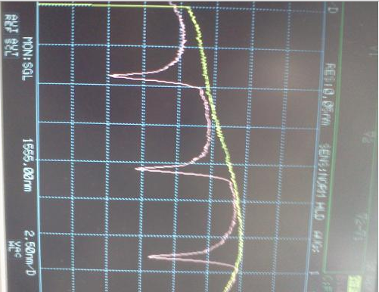
- If it is not adjusted correctly, use the tweezers to carefully adjust the horizontal position of the crystal to the left or right. It should be able to go anywhere on the etched region of the fiber, but pay close attention to where the OSA begins to output a gain and loss in power. Adjust the fiber until there is at least 15 dB. This could take some time to find the correct spot.

- If this process takes a long time, the UV glue could begin to get viscous, which makes the process of adjusting the crystal very difficult. To clean, put some acetone on the mirror. Loosen the fiber so that it rests in the acetone on the mirror. Let it sit for several minutes and wipe off the glue from the fiber and dry off the mirror. Reapply UV glue from the cue tip to the fiber and continue adjusting the crystal.

- Once the crystal is set up in the correct spot, turn on the UV lamp and place the light directly over the crystal. This will cause the UV glue to cure.

Packaging:
Materials:
- 5 minute epoxy
- Low Index Epoxy
- Package
Procedures:
- Wait for UV cure glue to be completely dry.
- Place the package underneath the crystal and the fiber. This must be done very carefully. Do not touch the sides of the package with the crystal or wire because it could knock the crystal out of place. The package will need to be propped up in a position so that the wire fits perfectly inside the gap running through it.
- Place 5 minute epoxy where the jackets end on the fiber. The epoxy should just barely touch the shiny part of the wire. No epoxy should get on the etched portion of the wire. If it does, the resonance on the OSA will return to zero. Monitor the OSA while placing on the epoxy to ensure that epoxy has not been added in the incorrect place.
- When the five minute epoxy has cured, place low index epoxy to cover the remainder of the fiber and the crystal. It is best to place the low index epoxy on the ends of glue and let it settle underneath the crystal. Placing glue on top of the crystal could cause it to be knocked out of place. Monitor the OSA to make sure there is still 15 dB of resonance. Put enough epoxy in the package to allow it to be flush with the top of the package.
- Let the low index epoxy settle. This could take several hours or overnight.
- Once the low index epoxy has settled, cut wire jackets to cover both ends of the fiber coming out of the package.
Connectorizing:
Connectorizing is placing attaching a connector to the end of the fiber so that it can be attached to many things.
Materials:
- Connector
- Piano wire
- Connectorizing epoxy
- Syringe
- Ultrasonic cleaner
Procedure:
- There are two ends to a connector. Ensure that the piano wire can be placed in one end and go out the other easily.
- If the piano wire fits through the connector, place the fiber through the connector, testing to see if it fits through easily. If it does not fit through the connector, it will need to be etched until they are thin enough to fit through. This will take approximately 100 seconds in the HF. After the first etching if the fiber does not fit, place it back in the HF for 30 additional seconds. The fiber must be cleaned in the ultrasonic cleaner before being connectorized.

- Place a cap on the fiber oriented so that the cap will be able to fit around a connector.

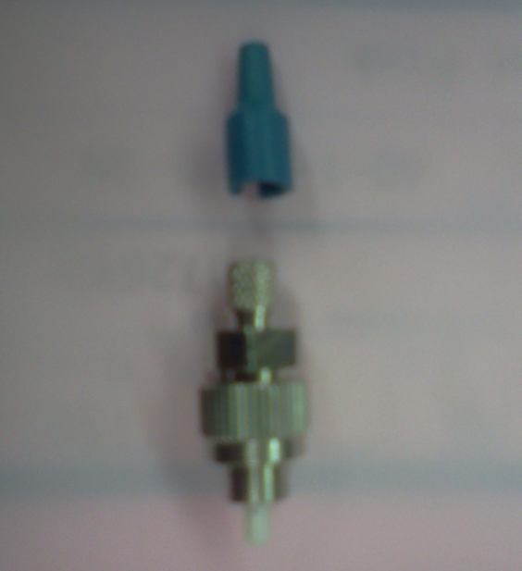

- The other end of the connector (the end that is not being connectorized) should be secure. Tape it somewhere so that it will not budge during the connectorizing or polishing process. Do not place any tape over the region of the fiber that is covered in epoxy. The epoxy is soft and if it moves, the crystal will be knocked out of place slightly and it will be impossible to put it back in place.
- Prepare connectorizing epoxy by mixing it and placing it into a syringe with a needle small enough to fit in the connector (through side without the ferrule).
- When the fiber can fit through the connector easily, remove it from the connector and fill the gap with connectorizing epoxy. When the epoxy begins to spill over the edge through which it is being applied, stop applying epoxy.
- Once the epoxy fills the gap in the connector, gently work the D fiber through the connector. This step requires time and patience. Do not allow the fiber to bend when placing it through the connector or it could break. DO NOT FORCE IT! Once the fiber has worked its way through the connector (etched region is partially sticking out of the ferrule and the fiber will no longer move), place a bit of epoxy on the tip of the ferrule surrounding the fiber that is sticking out the tip.
- Place the connector in the oven. When the epoxy at the tip of the ferrule is hardened, the connectorizing process is complete. Curing instructions are found on the package of epoxy.
Polishing
Materials:
- 5 micron sandpaper (white)
- 1 micron sandpaper (pink)
- .3 micron sandpaper (bluish-white)
- Polisher
- Distilled Water
- Pipette
- Polishing Stage
- Towels
- IPA
Procedure:
The polishing process can be long and tedious. The purpose of polishing is to remove the excess epoxy from the end of the fiber and smooth it out.
- Use a razor to cut the excess fiber off the end of the connector. There should still be some excess epoxy at the end.
- Cut the sandpaper down to the correct size. For the polishing stage at the BYU lab, the sandpaper can be cut into three pieces of equal sizes, each of which should be approximately equal in size to the glass portion of the stage. Polishing will require sandpaper from each grade of coarseness (5u, 1u, and 0.3u), so prepare a stage-sized piece of sandpaper for each of them.
- The first grade of sandpaper to be used is the coarsest, 5u. Clean off the sandpaper and the stage.
- Squirt enough IPA on the shiny side of the sandpaper as well as the glass portion of the stage. Wipe these down well with a towel. They should be (almost) dry. Place the shinier side of the sandpaper facing the glass. There should be enough IPA on the bottom side of the sandpaper to create a suction between stage and sandpaper. Note: Do not wipe down the course side of the sandpaper at this point.
- Apply enough IPA to cover the top side (coarse side) of the sandpaper. Apply IPA to the polishing side of the polisher. (This is the side with the etchings on it in the shape of a tic-tac-toe board).
- Dry off the polisher and the coarse side of the sandpaper using approximately 20 PSI of compressed air. The nozzle of the compressed air should be faced perpendicular to the paper or else the paper could be blown away. Dry the sandpaper and the polisher completely.
- It is time to start polishing. The connector can be placed into the polisher. The side with the epoxy that needs to be removed is placed though the hole in the center of the polisher and should come out on the polishing (tic-tac-toe) side. This will be placed (polishing side down) on the coarse side of the sand paper. Gravity should carry the string and epoxy to the base so it can be polished.

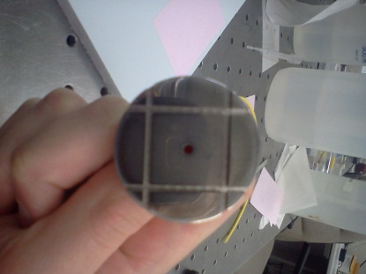
Figure 1- Polisher - Polishing Side
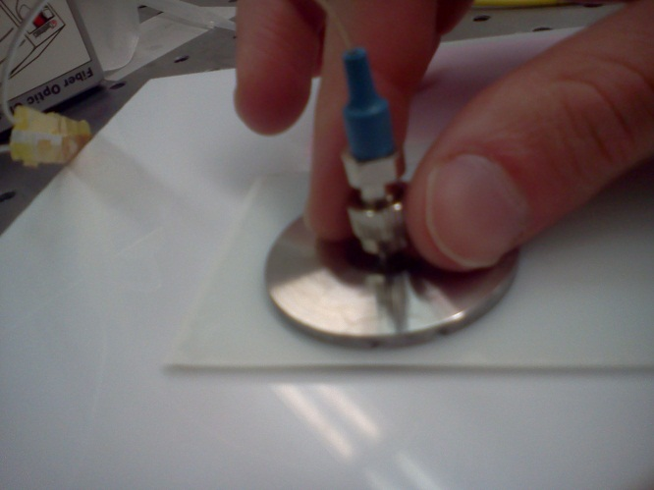
- Holding the sides of the handle with your finger and thumb and applying just a little pressure down, polish the connector by moving the polisher in figure 8 motions across the sandpaper. Use as much of the sandpaper as possible to get the maximum usage of the sandpaper but DO NOT let the connector go over the edge. This could remove all the epoxy at once. Continue with the figure 8 motions until almost all the epoxy has been removed. It should be flush with the end of the connector and have a very small layer of epoxy left. This could take a while to get to this point.

Figure 2- Hand Position for Polishing

- Next, use the 1u (pink) sandpaper. Remove the 5u sandpaper from the stage and repeat the preparation process (3-6) this time using the 1u sandpaper. Once these steps are completed, add three drops of distilled water to the coarse end of the sandpaper. Do the polishing stage as explained in step 8. This time the purpose is to remove all the epoxy from the end of the connector. This process should not take as long as step 8. It should only take 20 or 30 figure 8’s to remove all the glue.
- Repeat step 9 using the 0.3u (bluish-white) sandpaper. As with step 8, this should not take too many figure 8’s to complete the process. (Approximately 10 figure 8’s). The purpose of this stage is to smooth the surface of the fiber so that the core is visible through the microscope and
no contamination is present on the rest of the fiber.
- Check the end of the connector using the microscope. If the fiber has been polished correctly, it should look like the “D” shape in the microscope. The area with the core should be smooth and clean.
- If this is not the case, it has not been polished enough or something has broken in the fiber.
- Test to see if light comes through. (Actually, this should be done frequently throughout the process to ensure that nothing has broken within the fiber, or at elast to know when something breaks so that proper care can be taken next time).
- Test to see how much power comes through using the lightwave multimeter and the lightwave transmitter. Using couplers, attach the ends of the SCOS to the input (lightwave transmitter) and the output (lightwave multimeter). Check to ensure that power coming though is in the low mW range. If it is not, clean the ferrules and try again.
- If power is coming through the SCOS, test the resonance using the Optical Spectrum Analyzer.
  - Attach the ASE Source to the input of the polarizer.
  - Attach the output of the polarizer to the input of the SCOS.
  - Attach the output of the SCOS to the OSA.
  - Adjust polarization to achieve maximum resonance. (This must be done after it is keyed.)

Keying
- Hole punch some wax paper or double sided tape and place on the fiber microscope, along with an adaptor. Rotate the key so that it is vertical.
- Stick a drop of super glue on the notch so that it is vertical.

